**E-LIBRARY MANAGEMENT SYSTEM:**

**NAME:** IYESWARAN M **NAME:** GEETHA AVS

**REG NO:** RA2111009010100 **REG NO:** RA2111009010101

## **ALGORITHM:**

Step 1: Declare a structure which holds data members

Step 2: declare variables which are used for loop

Step 3: use switch case to work on each module

Step 4: case 1- for Adding book information

        Case 2- for Display book information

Case 3- for Finding number of books of given author

        Case 4- for Finding number for books in library

        Case 5- for EXIT

## **CODE:**

#include <stdio.h>

#include <stdlib.h>

#include <string.h>

struct library {

char book_name[20];

char author[20];

int pages;

float price;

};

int main()

{

struct library lib[100];

char ar_nm[30], bk_nm[30];

int i, input, count;

i = input = count = 0;

while (input != 5) {

printf("\n\n********######"

"WELCOME TO E-LIBRARY "

"#####********\n");

printf("\n\n1. Add book infor"

"mation\n2. Display "

"book information\n");

printf("3. List all books of "

"given author\n");

printf(

"4. List the count of book"

"s in the library\n");

printf("5. Exit");

printf("\n\nEnter one of "

"the above: ");

scanf("%d", &input);

switch (input) {

case 1:

printf("Enter book name = ");

scanf("%s", lib[i].book_name);

printf("Enter author name = ");

scanf("%s", lib[i].author);

printf("Enter pages = ");

scanf("%d", &lib[i].pages);

printf("Enter price = ");

scanf("%f", &lib[i].price);

count++;

break;

case 2:

printf("You have entered"

" the following "

"information\n");

for (i = 0; i < count; i++) {

printf("Book name = %s",

lib[i].book_name);

printf("\t Author name = %s",

lib[i].author);

printf("\t Pages = %d",

lib[i].pages);

printf("\t Price = %f",

lib[i].price);

}

break;

case 3:

printf("Enter author name : ");

scanf("%s", ar_nm);

for (i = 0; i < count; i++) {

if (strcmp(ar_nm,

lib[i].author)

== 0)

printf("%s %s %d %f",

lib[i].book_name,

lib[i].author,

lib[i].pages,

lib[i].price);

}

break;

case 4:

printf("\n No of books in "

"library : %d",

count);

break;

case 5:

exit(0);

}

}

return 0;

}

# **ONLINE C COMPILER:**

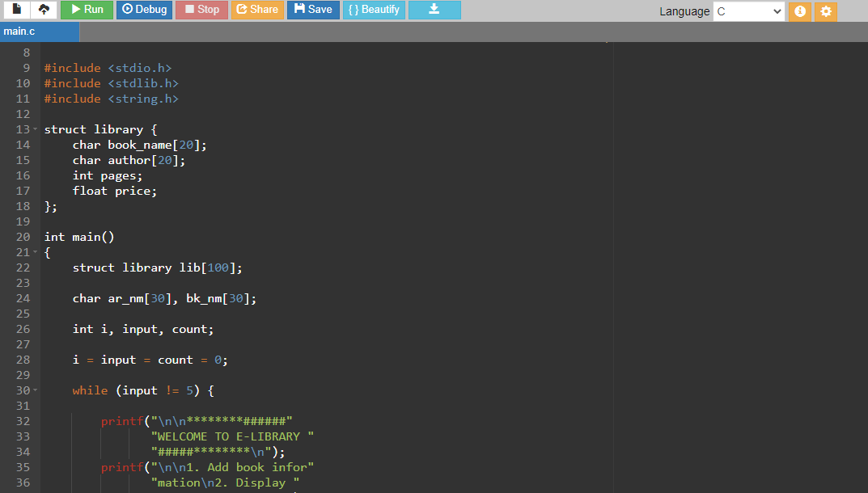

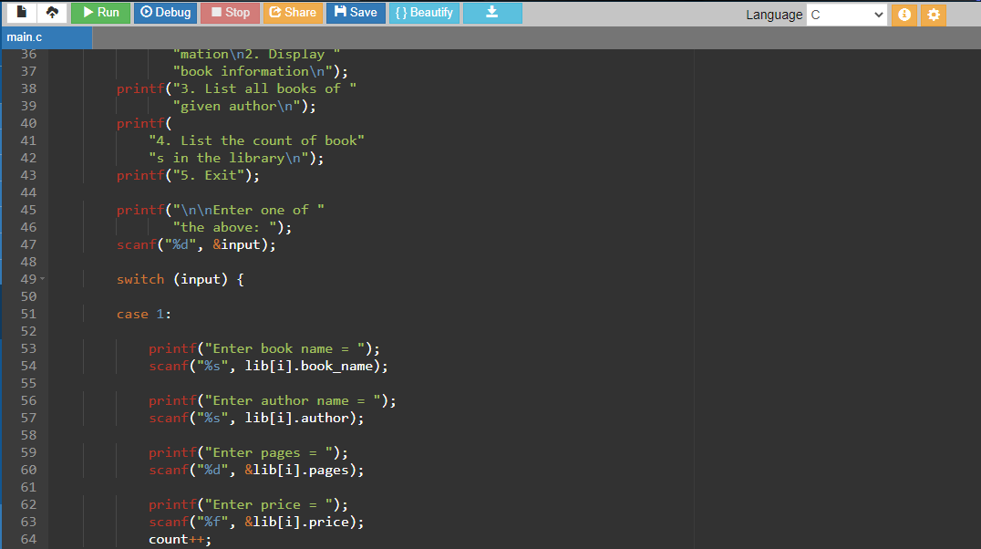

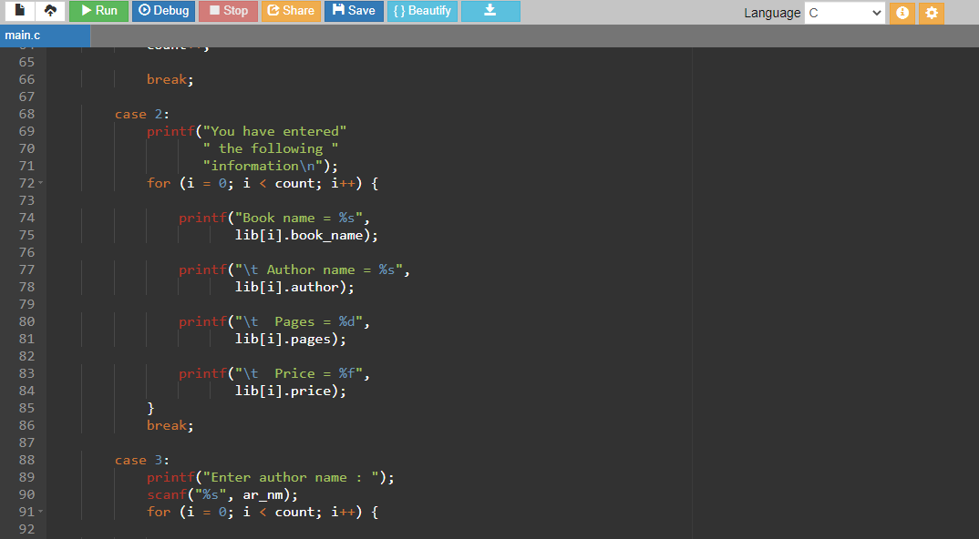

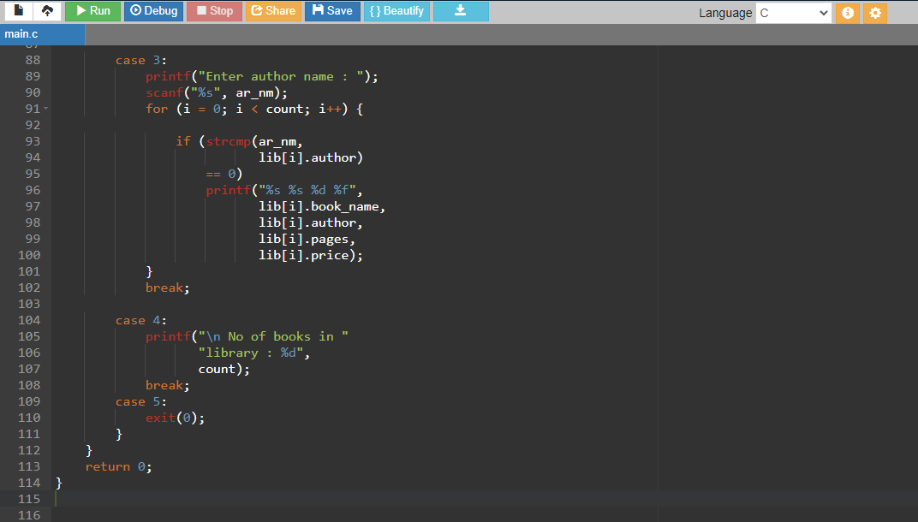

# **OUTPUT:**

## **FORMAT:**

1. Add book information

2. Display book information

3. List all books of given author

4. List the count of books in the library

5. Exit

Enter one of the above:

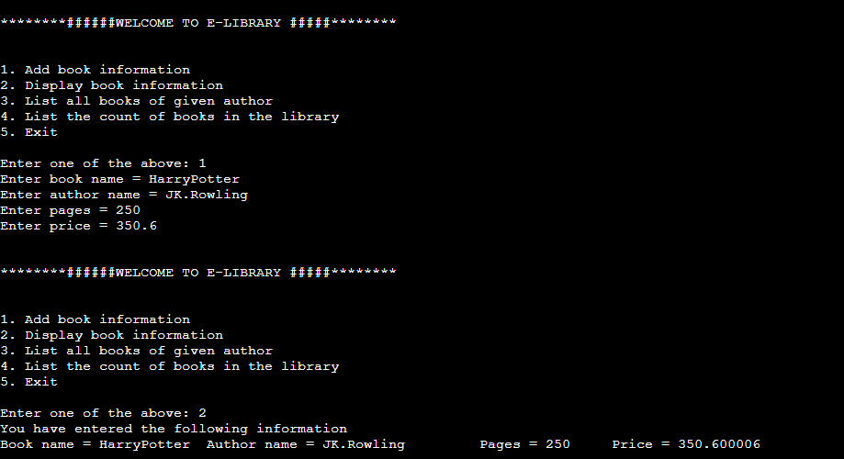

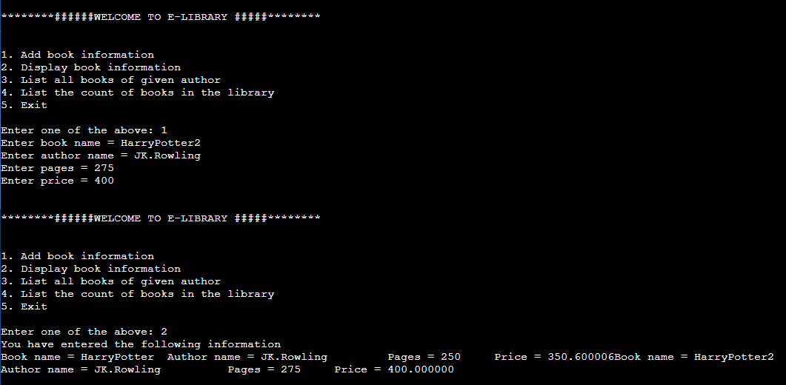

After displaying book information, we can list all books of given author and also list the count of books in the library by entering the respective cases.

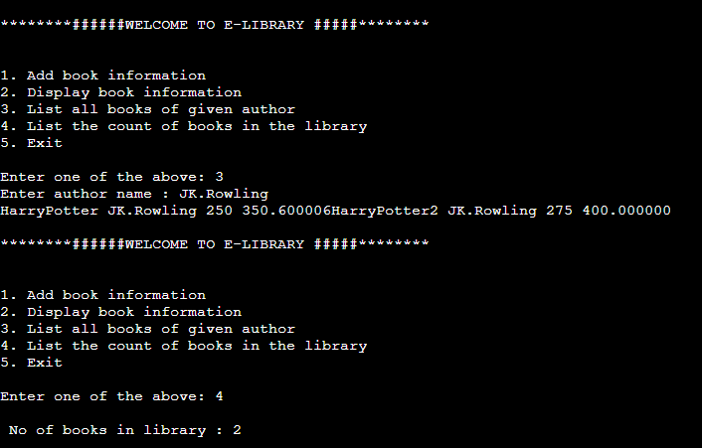

Exiting (Ending) the program via the exit code. (Case 5)

